**Lesson 1: Introduction to the Tangent and Rates of Change**

After completing this lesson, you should be able to

* define *tangent*
* define and discuss rates of change

**Commentary**

**Topics**

1. [The Tangent](https://content.umuc.edu/file/7bdece95-b196-4233-9313-aa904663b08e/1/MATH140-0909.zip/Modules/M2-Module_2/Lesson_1/S3-Commentary.html#I)
2. [Rates of Change](https://content.umuc.edu/file/7bdece95-b196-4233-9313-aa904663b08e/1/MATH140-0909.zip/Modules/M2-Module_2/Lesson_1/S3-Commentary.html#II)

**1. The Tangent**

We will begin our discussion with the tangent line and rates of change and how they lead to the concept of the *limit*.

The word **tangent** comes from the Latin *tangens*, meaning "touching." We say that the tangent line (or tangent) to a curve at a point *P* touches the curve at that point. To define the term, we may intuitively follow the convention of ancient Greek mathematicians, who defined *tangents* as lines that touch a circle at precisely one point, as shown in figure 2.1.1.

**Figure 2.1.1  
Line Touching a Circle at One Point**

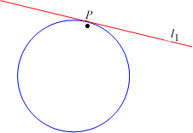

However, this definition does not suffice, as we can see when we look at figure 2.1.2a, where line *l*2 intersects the curve *C*at one point, but is not tangent to *C*; and in figure 2.1.2b, where line *l*3 intersects the curve *C* at several points, but is tangent to the curve *C* at *P*.

**Figure 2.1.2a  
Line That is Not a Tangent**

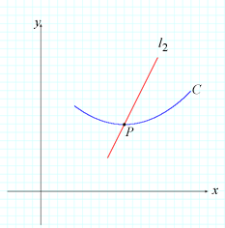

In the figure above, line *l*2 intersects the curve *C* precisely once; however, it is not tangent to *C*.

**Figure 2.1.2b  
Line That is a Tangent**

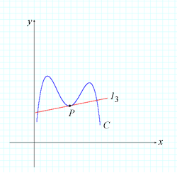

In the figure above, line *l*3 is tangent to the curve *C* at the point *P*, but intersects *C* at more than one point.

We think of a tangent as a line that touches a curve (most gently) at a single point, and yet the circle tangent concept is not quite sufficient. How can we make the definition of a tangent more precise? We can do this by observing the behavior of secants through the point *P* and points *Q* approaching the point *P* along the curve *C*. Consider the following exercise, in which we find a tangent line to the curve *y* = *x*2 at a particular point *P*.

**Exercise 2.1.1: Find the Tangent Line to a Curve**

**Problem**

Find the equation of the tangent line to the curve *y* = *x*2 at the point *P*(2, 4).

**Solution**

To find the equation of the tangent line given a point *P*(2, 4) on the line, we first find the slope of the tangent line. We find the slope at *P* by writing an expression for the slope of a secant line passing through *P*(2, 4) and a nearby point *Q*(*x*, *x*2), and by letting *Q* approach *P* along the curve *y* = *x*2 by letting *x* approach 2 (without letting *x* equal 2). Here is our expression:

https://content.umuc.edu/file/7bdece95-b196-4233-9313-aa904663b08e/1/MATH140-0909.zip/Modules/M2-Module_2/Lesson_1/images/Math140Lesson2-ex2-1-1-eq.gif

Tables 2.1.1a and 2.1.1b show that, as *Q*(*x*, *x*2) nears *P*(2, 4) from the left and from the right, the slope of the secant approaches 4. This suggests that the slope of the tangent line is 4.

|  |  |  |  |  |  |  |  |  |  |  |  |  |  |  |  |  |  |  |  |  |  |  |  |  |  |  |  |  |  |
| --- | --- | --- | --- | --- | --- | --- | --- | --- | --- | --- | --- | --- | --- | --- | --- | --- | --- | --- | --- | --- | --- | --- | --- | --- | --- | --- | --- | --- | --- |
| **Table 2.1.1a Approaching From the Left**   |  |  | | --- | --- | | ***x*** | **Slope of Secant** | | 1 | 3 | | 1.5 | 3.5 | | 1.75 | 3.75 | | 1.9 | 3.9 | | 1.99 | 3.99 | | 1.999 | 3.999 |   As *Q*(*x*, *x*2) nears *P*(2, 4) from the left, the slope of the secant approaches 4. | **Table 2.1.1b Approaching From the Right**   |  |  | | --- | --- | | ***x*** | **Slope of Secant** | | 3 | 5 | | 2.5 | 4.5 | | 2.25 | 4.25 | | 2.1 | 4.1 | | 2.01 | 4.01 | | 2.001 | 4.001 |   As *Q*(*x*, *x*2) nears *P*(2, 4) from the right, the slope of the secant approaches 4. |

The slope of the tangent line is the "limit" of the slopes of the secant lines, determined by moving a nearby point on the curve closer to the tangent point. The step diagram below will walk you through the limiting process for our exercise, where the point *Q* approaches the point *P*. As you will see, the slopes of the secant lines approach the slope of the tangent line as the point *Q*gets closer and closer to *P*.

Click on the step diagram to see the limiting process.

**2. Rates of Change**

As we travel from one place to another, we may speed up, slow down, and/or stop. The rate at which we travel over a period of time is our **average velocity**. We determine the average velocity of an object by dividing the distance traveled by the time elapsed.

In calculus, we can also examine velocity at a particular moment in time, or **instantaneous velocity**. Let us perform the following exercise to help us conceptualize both average and instantaneous velocity.

**Exercise 2.1.2: Determine the Velocity of a Falling Object**

Suppose we just dropped a penny from Baltimore's World Trade Center, which at 423 feet is the world's tallest equilateral five-sided building.

**Problem**

1. Determine the average velocity of the penny during the two-second interval *t*= 1 and *t* = 3 seconds.
2. Determine the velocity of the penny three seconds after it was dropped.

**Solution**

1. Over 400 years ago, Giovanni Benedetti and Galileo Galilei established that the distance a falling object travels is proportional to the square of the time it has traveled. This can be reasonably approximated by

*s*(*t*) = 16*t*2

where *s*(*t*) is the distance (in feet) the object has fallen, and *t* is the time it has fallen (in seconds).

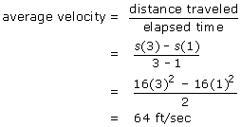

The average velocity of the penny during the two-second interval *t*= 1 and *t* = 3 seconds is 64 ft/sec.

1. The challenge of finding the velocity of an object at a particular moment in time (in this case, *t*= 3) is that we do not have an interval of time, or elapsed time. However, we can use a small interval of time, say 0.1 sec, from *t*= 3.0 to *t*= 3.1, to find an average velocity that approximates the instantaneous velocity.

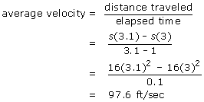

If we consider average velocity over successively shorter intervals of time (for example, 0.1, 0.01, 0.001, and so on), the average velocity becomes closer to the instantaneous velocity.

Table 2.1.2 shows the average velocity of the penny over successively smaller intervals of time.

**Table 2.1.2  
Average Velocity Over Successively Smaller Time Intervals**

|  |  |
| --- | --- |
| **Time Interval** | **Average Velocity** |
| 3 ≤ *t* ≤ 3.1 | 97.6 |
| 3 ≤ *t* ≤ 3.01 | 96.16 |
| 3 ≤ *t* ≤ 3.001 | 96.016 |
| 3 ≤ *t* ≤ 3.0001 | 96.002 |

Table 2.1.2 shows that, as the intervals of time become smaller, the average velocity becomes closer to 96 ft/sec. The instantaneous velocity at *t*= 3 seconds is the limiting value of the average velocities over the successively smaller intervals of time that began at *t*= 3 seconds.

The velocity after three seconds, or the instantaneous velocity at *t*= 3 seconds, is 96 ft/sec.

**Note This**

|  |  |
| --- | --- |
| https://content.umuc.edu/file/7bdece95-b196-4233-9313-aa904663b08e/1/MATH140-0909.zip/Modules/M2-Module_2/Lesson_1/images/NoteThisIcon.png | When distance is given in meters (m), we write the equation *s*(*t*) = 9.8*t*2 to describe the relationship between the distance traveled of a free-falling object (in meters) and the time elapsed (in seconds). |

Note that this model for free-falling objects does not take into account air resistance.

Figures 2.1.4a and 2.1.4b show graphs of average and instantaneous velocity, respectively:

|  |  |
| --- | --- |
| **Figure 2.1.4a Average Velocity**  **https://content.umuc.edu/file/7bdece95-b196-4233-9313-aa904663b08e/1/MATH140-0909.zip/Modules/M2-Module_2/Lesson_1/images/Math140Lesson2-2-1-4a.png** | **Figure 2.1.4b Instantaneous Velocity**  **https://content.umuc.edu/file/7bdece95-b196-4233-9313-aa904663b08e/1/MATH140-0909.zip/Modules/M2-Module_2/Lesson_1/images/Math140Lesson2-2-1-4b.png** |

Graphically, the rate of change of a function over an interval [*x*1, *x*2] is the slope of the line passing through the points (*x*1, *f*(*x*1)) and (*x*2, *f*(*x*2)), as shown in figure 2.1.5 below.

**Note This**

|  |  |
| --- | --- |
| https://content.umuc.edu/file/7bdece95-b196-4233-9313-aa904663b08e/1/MATH140-0909.zip/Modules/M2-Module_2/Lesson_1/images/NoteThisIcon.png | The average rate of change of a function *f* over the interval [*x*1, *x*2] is the slope of the secant line:  https://content.umuc.edu/file/7bdece95-b196-4233-9313-aa904663b08e/1/MATH140-0909.zip/Modules/M2-Module_2/Lesson_1/images/slope-secant-line.gif |

**Figure 2.1.5  
Secant Line**

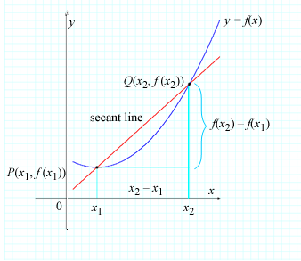

Velocity is not the only example of a rate of change. The average rate of change of one quantity, say, *y* = *f*(*x*), with respect to *x* over the closed interval [*x*1, *x*2], is

**https://content.umuc.edu/file/7bdece95-b196-4233-9313-aa904663b08e/1/MATH140-0909.zip/Modules/M2-Module_2/Lesson_1/images/avg-rte-change-slope-secant-line.gif**

The instantaneous rate of change of *f*(*x*) with respect to *x* is the limit of the average rates of change. We estimate the instantaneous rate of change by considering the average rate over smaller and smaller intervals.

In the following exercise, we will apply both average and instantaneous rates of change.

**Exercise 2.1.3: Find the Rate of Growth of a Disease**

Table 2.1.3 shows a projection of the growth rate of the deadly Ebola virus in a small city with an initial population of 120,000 if the virus were left untreated after *x*weeks. (This projection is based on information from the Centers for Disease Control and Prevention [CDC], although the figures are made up for the purposes of this exercise.)

**Table 2.1.3  
Ebola Virus Growth Rate**

|  |  |
| --- | --- |
| ***x* (Weeks)** | ***P* (People Infected)** |
|  | 5,714 |
| 0.5 | 11,486 |
| 1 | 21,968 |
| 1.5 | 38,610 |
| 2 | 60,128 |
| 2.5 | 81,613 |
| 3 | 98,185 |
| 3.5 | 108,602 |
| 4 | 114,332 |
| 4.5 | 117,254 |
| 5 | 118,687 |
| 5.5 | 119,376 |
| 6 | 119,705 |

**Problem**

1. Use the data in table 2.1.3 to sketch a graph of this function, and estimate the average growth rate of the disease from week 2 to week 4.
2. Estimate the growth rate of the disease during week 4.

**Solution**

1. We plot the data in table 2.1.3 and connect the data points with a smooth curve that reasonably approximates the graph of the function.

**Figure 2.1.6  
Population Infected with Ebola Virus Over Time**

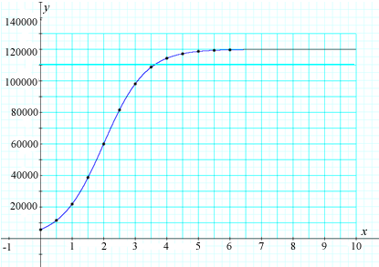

The average growth rate (or average rate of change) from week 2 to week 4 is the slope of the secant line through points*P*(2, 60128) and *Q*(4, 114332), namely, *mPQ* (see figure 2.1.7).

average growth rate = https://content.umuc.edu/file/7bdece95-b196-4233-9313-aa904663b08e/1/MATH140-0909.zip/Modules/M2-Module_2/Lesson_1/images/avg-grwth-rate.gif

**Figure 2.1.7  
Average Growth Rate of Ebola Virus**

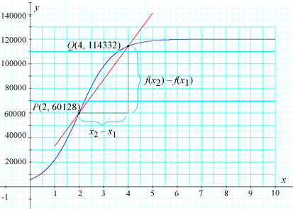

1. To estimate the growth rate of the disease during week 4, we examine the slopes of the two secant lines closest to week 4 (associated with the closest time intervals to the left and to the right of week 4). See table 2.1.4 and figure 2.1.8:

**Table 2.1.4  
Two Secant Lines Closest to Week 4**

|  |  |  |
| --- | --- | --- |
| ***P*** | ***Q*** | ***mPQ*** |
| (3.5, 108602) | (4, 114332) | 11460 |
| (4.5, 117254) | (4, 114332) | 5844 |

**Figure 2.1.8  
Week 4 Ebola Virus Growth Rate**

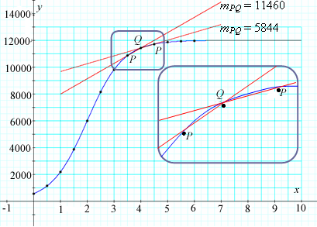

It is reasonable for us to assume that the slope of the tangent line on week 4 lies somewhere between 5844 and 11460 on the graph. We use the average of the slopes of the two nearest secant lines to week 4 to estimate the slope of the tangent line:

https://content.umuc.edu/file/7bdece95-b196-4233-9313-aa904663b08e/1/MATH140-0909.zip/Modules/M2-Module_2/Lesson_1/images/tangentline.gif

Using the average of the slopes of the two nearest secant lines, we estimate the slope of the tangent line to be 8652. Thus, approximately 8,652 people will become infected during the fourth week, according to our projection.

**Question to Ponder:**Why does the growth rate begin to level off in week 4 after climbing steadily between week 2 and week 4?

**Exercise 2.1.4: Estimate the Velocity of an Ascent**

Located in the Himalayan mountain range that borders Pakistan, China, and India, K2 is the world's second-highest and most dangerous mountain. The earliest known successful ascent to the summit took place on July 31, 1954. Figure 2.1.9 shows the distance (in meters) the team of climbers traveled.

**Problem**

Determine the average rate of ascent from point *A* (Base Camp) to point *B* (Camp IV).

**Solution**

First, we look at a graph of the ascent:

**Figure 2.1.9  
Distance and Time From Point *A* to Point *B***

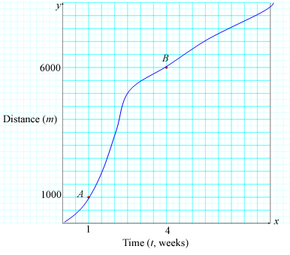

Then, we calculate the average velocity:

**https://content.umuc.edu/file/7bdece95-b196-4233-9313-aa904663b08e/1/MATH140-0909.zip/Modules/M2-Module_2/Lesson_1/images/Math140-m2-lesn1-ex2-1-9-eq.gif**

**Figure 2.1.10  
Average Velocity of Ascent**

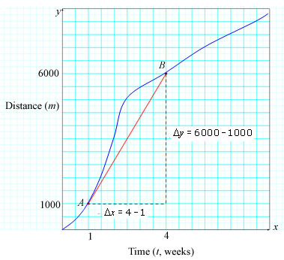

To find an approximation of the instantaneous velocity, we construct an approximation of the tangent line at *P*(4, 6) and find the approximate length of the legs of the right triangle *PQR*.

https://content.umuc.edu/file/7bdece95-b196-4233-9313-aa904663b08e/1/MATH140-0909.zip/Modules/M2-Module_2/Lesson_1/images/instant-velocity-eq.gif

**Figure 2.1.11  
Instantaneous Velocity of Ascent**

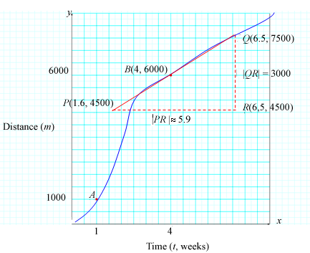

[*Return to top of page*](https://content.umuc.edu/file/7bdece95-b196-4233-9313-aa904663b08e/1/MATH140-0909.zip/Modules/M2-Module_2/Lesson_1/S3-Commentary.html#pagetop)

[**Report broken links or any other problems on this page.**](http://help.umuc.edu/)  
  
[**Copyright © by University of Maryland University College.**](https://content.umuc.edu/file/7bdece95-b196-4233-9313-aa904663b08e/1/MATH140-0909.zip/common/copyright.html)